CyberStock Manual

Where is the project?

* The project is located in “C:\xampp\htdocs\src_tf\CyberStock”
* The Pages for the project are in the Pages folder
* All plugins that we use for the project are in the Vendor folder. Some subfolders are dependent on others

How do I start the project?

1. Start the command line
   1. Enter “mongod”
   2. This will start the db
2. Open an instance of “xampp”. It should be on the taskbar
   1. Once xampp is opened. Press the start button next to the Apache module.
   2. If Apache is already started the button will say Stop. You can restart it by pressing stop and start again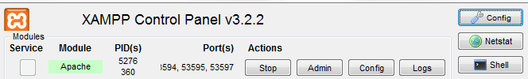
3. Open a browser of your choice
   1. In the address bar, type <http://localhost/src_tf/CyberStock/Pages/TwitterFingerz.php> this will open the web page

How do I update the project?

1. Open a file explorer window
2. Navigate to the project at “C:\xampp\htdocs\src_tf\CyberStock”
3. Right click inside the project then press “GIT Bash Here” 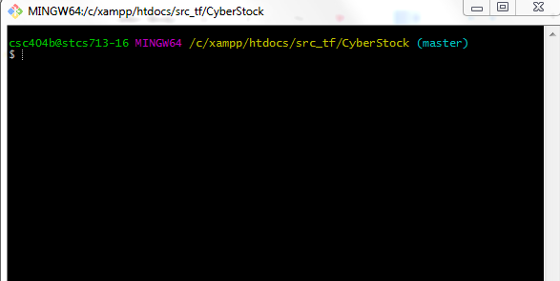
4. You should see the above window
5. From here, type “git pull”
   1. If the project is already up to date, it will say “already up-to-date”
   2. If is not updated, it will begin to download updates
6. If you want to see a changelog of all updates type “git log” 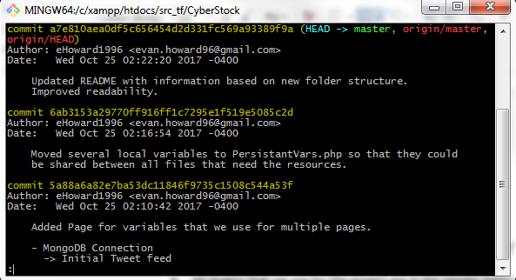
7. The above screen will appear
   1. To return to the previous screen, type “q”

How do I add my own updates?

1. From the git window type “git status”
   1. This will bring up a list of changes that have been made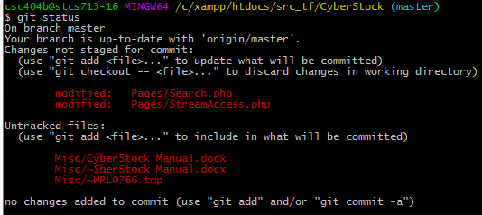
   2. Changes that are “not staged for commit” will not be uploaded to the project when you push. Changes that are “staged for commit” will be uploaded. “Untracked changes” are files that you added to the project folder that you did not upload to git.
   3. To “stage a file for commit” type “git add <file_name>”. For example, if you want to add “Pages/Search.php” to the commit type “git add Pages/Search.php”. We can keep adding files manually for commit by using the above method. Or we can add the whole list of files by typing “git add .”. This will add all “unstaged” files to our commit.
   4. The best thing to do for add files to a commit is to group all related files and functions under one commit. This way if we need to revert we aren’t destroying working functions.
2. Once we add, do “git status” again
   1. The below window should show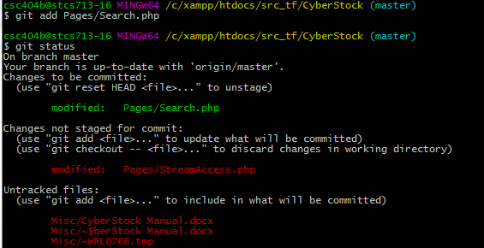
3. Now if we want, we can commit by typing “git commit” you should see the screen below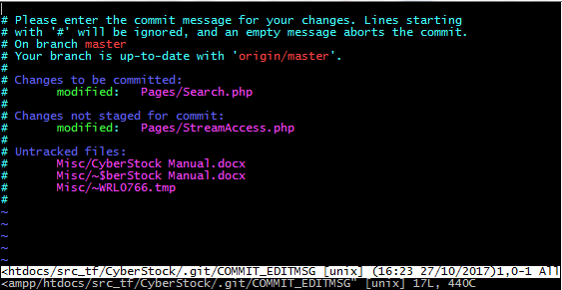
   1. On this screen, type a description of changes that you made in the commit. If you can’t type, try pressing the insert button. Once you are done typing your description press “esc” and then type “wq!” This means Write/Quit and the “!” means quit with no warnings. Typing just “q!” does not save changes to the description of the commit.
4. Once this is done enter “git status” again. You should see the screen below as well as any other unstaged changes.
5. To push your changes, first to “git pull” to make sure you aren’t overwriting other changes.
6. Then enter “git push”. This will upload all changes in your commit.

I accidentally staged a commit, what do I do?

1. In git, enter “git reset <file>” this will unstage “<file>” from the commit. Or you can enter “git reset” to unstage all files in the commit.